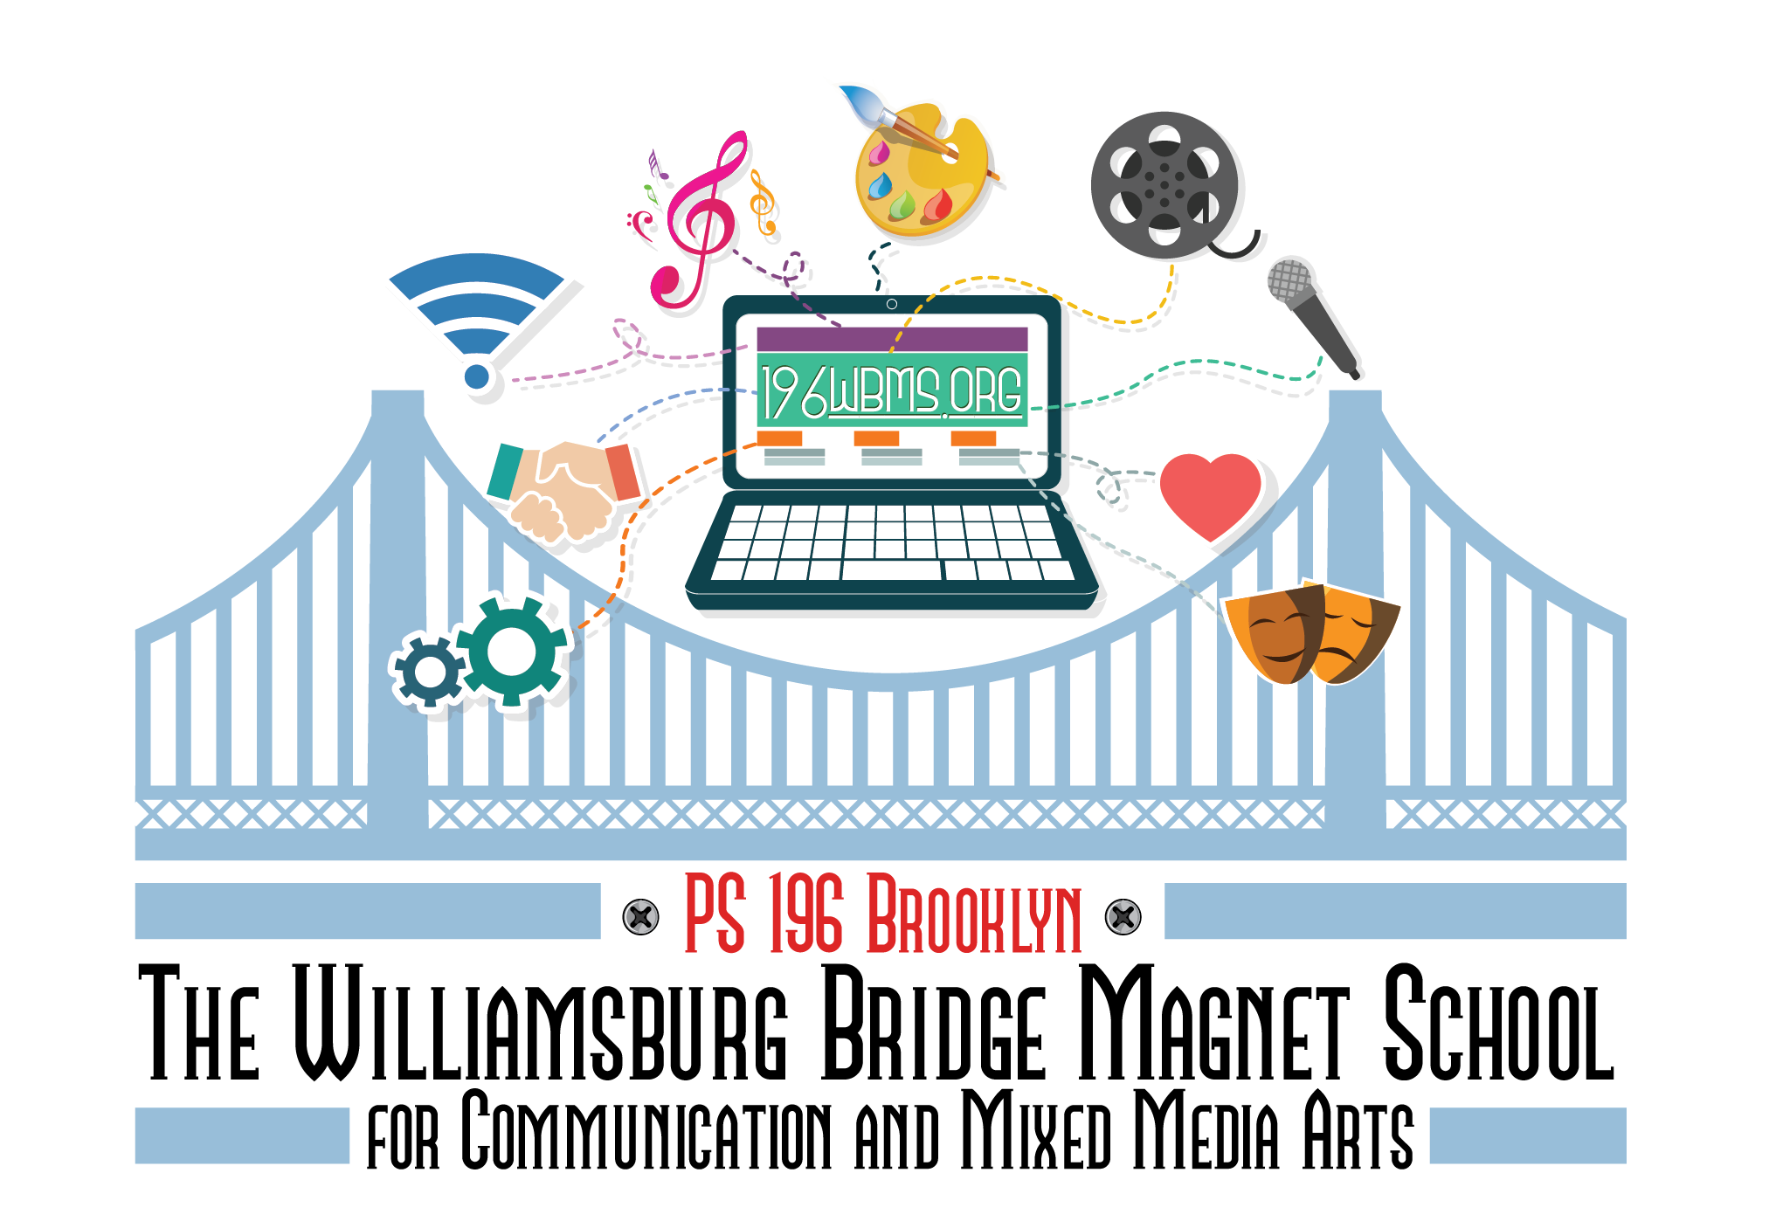

**Parent Guide to a Safe and Successful School Year**

**2023-2024**

September 2023

Dear Families,

Welcome Back! I hope that everyone had a wonderful and restful summer break. We are so happy to be back in school together again. Attached you will find the 196WBMS Parent Handbook for the 2023-2024 school year. Please read it over and review all of our protocols and procedures. I would like to thank you in advance for all of your cooperation and support. Should you ever have any questions or concerns please reach out to your child’s teacher. You can also reach out to our Parent Coordinator, Maria Rodriguez at [Mrodriguez3@schools.nyc.gov](mailto:Mrodriguez3@schools.nyc.gov). We, at 196WBMS, are looking forward to a very successful and productive school year ahead!

Educationally Yours,

Janine Colon

**Table of Contents**

Visitor Policy

Student Blue Cards

Medication at School

Arrival and Dismissal Procedures

2023-2024 School Year Calendar

COVID Guidelines 2023-2024

Breakfast and Lunch Procedures

Attendance Policy

Requesting School Letters

Grading Policy

Dress Code Policy

Student Privacy Annual Notice

Discipline Code

Academic Programs

I-Ready Family Guide

Social-Emotional Learning

School Safety Plan

School Safety Agents

Emergency Readiness

Brighter Bites/School Programming

Technical Support for families

NYC Schools Account (NYSCA)

Mental Health and Social- Emotional Wellbeing

Resources to Navigate Stress & Uncertainty

## 

## **Visitor Policy**

All visitors must enter through the main doors of the school building on Bushwick Ave. Upon entering the building, visitors must show proof of identification. Parents will sign in and be directed to the 196WBMS main office for further direction.

## **Student Blue Cards**

All students must complete a BLUE EMERGENCY CARD on the first day of school. These cards are crucial in an emergency. Please be sure to list 3 different phone numbers and an email address where a parent/guardian can be reached. Once completed, these cards will remain in the main office. If there are any changes to the student’s personal information, please contact the main office immediately.

## **Medications at School**

* All students with a medical condition such as asthma, severe allergies, or diabetes should submit a Medication Administration Form to the school.
* Submitting a Medication Administration Form enables the school nurse to treat your child in the case of a medical emergency.
* Even if your child can take his/her own medicine, it is important for the school clinical team to be aware of the student’s medical needs in case of an emergency.
* Medication Administration Forms are accepted on a rolling basis. You must submit a new Medication Administration Form each school year.

## **Arrival and Dismissal Procedures**

All students are expected to arrive on time to school each day. Free breakfast is served in the school cafeteria at 7:30 am. Please drop your child off at the main entrance if you would like them to receive breakfast. Please see the charts below for arrival and dismissal times and locations.

**196WBMS Arrivals**

| **Grade** | **Location** | **Time** |
| --- | --- | --- |
| 3K | In the classroom | 8:00am |
| Pre-K | In the classroom | 8:00am |
| Kindergarten | Side Doors / Meserole St.  Close to playground | 8:00am |
| 1st Grade | Side Doors/ Meserole St. | 8:00am |
| 2nd Grade | Side Doors/ Meserole St. | 8:00am |
| 3rd Grade | Side Doors/ Meserole St.  Corner by Bushwick Ave | 8:00am |
| 4th Grade | Side Doors/ Meserole St. | 8:00am |
| 5th Grade | Side Doors/ Meserole St. | 8:00am |

Students that arrive for breakfast at 7:30 can enter through the main doors on Bushwick Ave. and proceed to the cafeteria. Parents are not permitted in the cafeteria during breakfast.

3K-Prek students will be escorted to the classroom by a parent/guardian. Students in grades K- 2 will line up in the Gym and be picked up by the classroom teacher. Students in grades 3-5 will go directly to the classroom.

**Dismissal Procedures**

Please see the chart below for

grade specific staggered dismissal times and locations. Teachers will have students ready for pickup at these designated times.

| **Grade** | **Location** | **Time** |
| --- | --- | --- |
| 3K | Side doors/Meserole St  Close to park | 2:10pm |
| Pre-K | Side doors/Meserole St  Close to park | 2:10pm |
| Kindergarten | Ten Eyck Park | 2:10pm |
| 1st Grade | Ten Eyck Park | 2:15pm |
| 2nd Grade | Ten Eyck Park | 2:15pm |
| 3rd Grade | Ten Eyck Park | 2:15pm |
| 4th Grade | Side Doors/ Meserole St. | 2:15pm |
| 5th Grade | Side Doors/ Meserole St. | 2:15pm |

## 

## **2023-2024 School Year Calendar**

## **COVID Guidelines 2023-24**

This guidance provides best practice considerations for schools for the 2023-2024 school year to help prevent the transmission of COVID-19 among students and staff.

**Vaccination:** Vaccination is the best way to reduce COVID-19 risk. Encourage up to date COVID-19 vaccination for everyone six months or older.

**Vaccination Requirements**

Vaccination is still required for all DOE employees

Vaccination is still required for other individuals who work in DOE buildings

**Daily Health Screener:**

No longer required to enter school buildings

**Stay home if sick:** Students and staff should stay home if they show any symptoms of COVID-19 or other illnesses and get tested for COVID-19.

**Isolate if COVID-19 positive:** Students and staff who test positive for COVID-19 must isolate for 5 days and can return to school on day 6 if they have no symptoms or symptoms are improving. They should wear a mask until day 10 after symptom onset or date of positive test, whichever is earlier.

These cases should be reported to their school so they can be report into the sit room for exposure notifications.

**Get tested if exposed to COVID-19:** Students and staff who are exposed to COVID-19 should get tested.

These individuals should receive home tests from their school and take two tests, at least 24 hours apart on day 4 and day 5 of their exposure. All exposed individuals should monitor for fever and other COVID-19 symptoms for 10 days after their exposure. If symptoms begin, they should not attend school and should isolate and get tested for COVID-19 again right away.

**Masking:** Face coverings are strongly recommended to be worn when indoors. Masks will be made available at the school for all those who need/want them.

Students and staff, regardless of vaccination status, are required to wear a mask when:

Returning to school on the sixth day after testing positive for COVID-19, through day 10 after symptom onset or date of positive test, whichever is earlier, including when traveling on a school bus.

Entering the school medical room, nurse’s office, or school-based health center.

Exhibiting symptoms of COVID-19 at school.

Students and staff, regardless of vaccination status, are strongly recommended to wear a mask:

When they were exposed to someone with COVID-19, whether the exposure occurred in school or outside of school. The person should wear a mask for 10 days after their last day of exposure and get tested at least 24 hours apart on day 4 and day 5 of their exposure.

When they are moderately-to-severely immunocompromised, and masking is recommended by their healthcare provider.

In crowded indoor settings

**Ventilation:**

160K+ air purifiers distributed to schools – at least one in every classroom

Monitoring ventilation in buildings on a daily basis and perform any required work in a timely manner

HVAC upgrades in alignment with CDC guidance, including 110,000 MERV-13 filters installed

**School Building Cleaning:**

Routine cleaning of surfaces will be maintained

## 

## **Lunch Program**

Lunch will be provided to all students each day. We no longer serve peanut butter and jelly sandwiches. We provide sunflower and jelly sandwiches. 3K and Pre-K students will each lunch in the classroom during their lunch periods. Students in Kindergarten through grade 5 will eat lunch in the cafeteria. The lunch period consists of 50 minutes (25 minutes to eat and 25 minutes of outdoor recess, weather permitting).

## **Attendance Policy**

This school year we are emphasizing the importance of being at school, every day. With regular attendance, students will learn the skills and habits to succeed in their academic and social lives. Regular attendance boosts your child’s confidence, keeps your child on track with school work, and keeps your child healthy. NY state regulations require schools to maintain records that verify students’ attendance. Chronic absenteeism negatively impacts your student’s school career. Please note that regular attendance is the best way to ensure your child’s success.

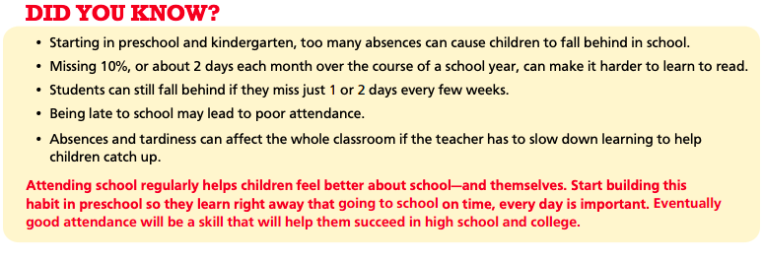

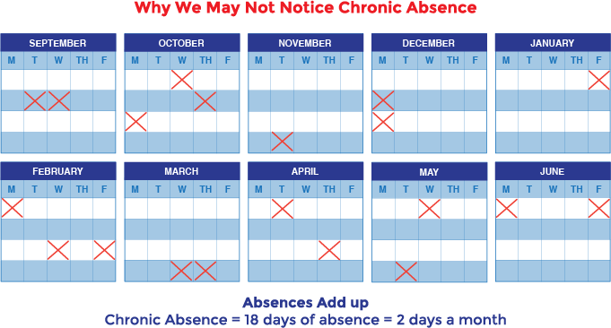

The classroom teacher will take attendance daily. In the event that a student must be absent a note either from a parent or doctor must be sent in with the child upon their return to school. We need your help in getting your student here every day. There are a few resources/tips and tricks that you can use to keep your children healthy, boost their confidence, protect against bullies, and on track.

**Boost Your Child’s Confidence**

**Tips for Building Confidence**

1. Appreciate effort no matter if they win or lose
2. Encourage practice to build competence
3. Let them figure out problems by themselves
4. Let them act their age
5. Encourage curiosity
6. Give them new challenges
7. Avoid creating shortcuts or making exceptions for your child
8. Never criticize their performance
9. Treat mistakes as building blocks for learning
10. Open the door to new experiences
11. Teach them what you know how to do
12. Don’t tell them when you’re worried about them
13. Praise them when they deal with adversity
14. Offer your help and support, but not too much of it
15. Applaud their courage to try something new
16. Celebrate the excitement of learning
17. Be authoritative, but not too forceful or strict

**Signs of stress in children**

1. Headaches or stomach aches
2. Sleep difficulty or nightmares
3. Avoiding peers or family activities
4. Not being able to focus on tasks
5. A drop in grades; and
6. Changes in emotions (for example: bad tempered, more grouchy than usual)

You can help children reduce stress by: making sure they get enough rest, walk them through what to expect in new situations, avoid having your children involved in too many activities or responsibilities, teach them healthy ways to deal with stress such as breathing techniques or exercise, and be patient.

**Keep Your Child On Track With School Work**

Children who are struggling with schoolwork can become frustrated and look for ways to avoid going to school. Our goal is to provide them with the support they need so they feel good about learning and good about themselves. Parents and teachers need to work together to help children succeed in school and feel connected.

As a parent you can promote habits for learning such as helping children get organized, teaching them to focus and concentrate, helping children prepare for tests, and encouraging year-long learning even in the summer.

Stay in touch/communication with your child’s teacher in order to foster a healthy partnership in your child’s learning.

**Keep Your Child On Track With School Work**

There are times when children need to miss school due to typical childhood illnesses. However, when many health issues are managed, we can reduce the amount of time children are out of school.

PS 196K offers free vision screenings and eye glasses every school year. We also have a partnership with NYU Langone that provides an in-school dental clinic. Students do not have to miss school time for vision and dental checkups and care.

**When children are too sick for school**

**Children are too sick for school if they:**

* Are uncomfortable and have a fever or green or yellow mucus, you may want to keep them home until they feel better.
* Have clear mucus and no fever but complain of a sore throat, you may want to call the doctor’s office for an appointment to rule out strep throat but if children are awake and otherwise fine, you could send them to school that day.

**Be ready for when children are too sick for school:**

* Before children are sick, write a list of babysitters for sick days if you cannot stay home from work.
* Find out if there is ‘sick-care’ in your city, town, or area.
* Save a few (paid or unpaid) personal days for your children when they are sick.
* Make a plan with another parent in your school or neighborhood to take children when they are sick or need to be picked up early from school.

## **Request for School Letter**

Contact the school and schedule an appointment in advance to request a school letter. Come in person and bring proof (letter/email) from the agency requesting the school letter.

## **Grading Policy**

Academic achievement is based on the mastery of the Next Generation Learning Standards. These standards address the skills and concepts that are needed for successful performance in all grades. A student’s final grade includes several different factors such as: class participation, effort, classwork, homework quizzes and tests. Teachers will use all of these components to reach a final score.

**P.S 196 WBMS Grading Policy Guide**

**2023-2024**

**How is your child being graded?**

Student academic achievement is based on mastery of the common core learning standards and New York State (NYS) Learning Standards for each subject. These standards address the skills and concepts that are needed for successful performance in all grades.

Assignments, tests, projects, classroom activities, and other instructional activities will be designed so that the student’s performance indicates the level of mastery of the Next Generation Learning Standards. The student’s mastery level of these standards will then be reflected in their classroom scores and report card grades.

Subjects that will be graded are English Language Arts (reading, literature, oral language, writing, handwriting, spelling), Mathematics, Science, Social Studies, Physical Education, Technology and Art.

Grades should be fairly determined from a wide variety of information, which could include student performance

on daily assignments/homework, tests, special projects, class participation, attendance and effort. Before instruction, students should be informed of the class expectations, and the teacher must be prepared to document and describe how grades are determined.

**Grading Scale in Class – K to 5th Grade**

Please see the chart: 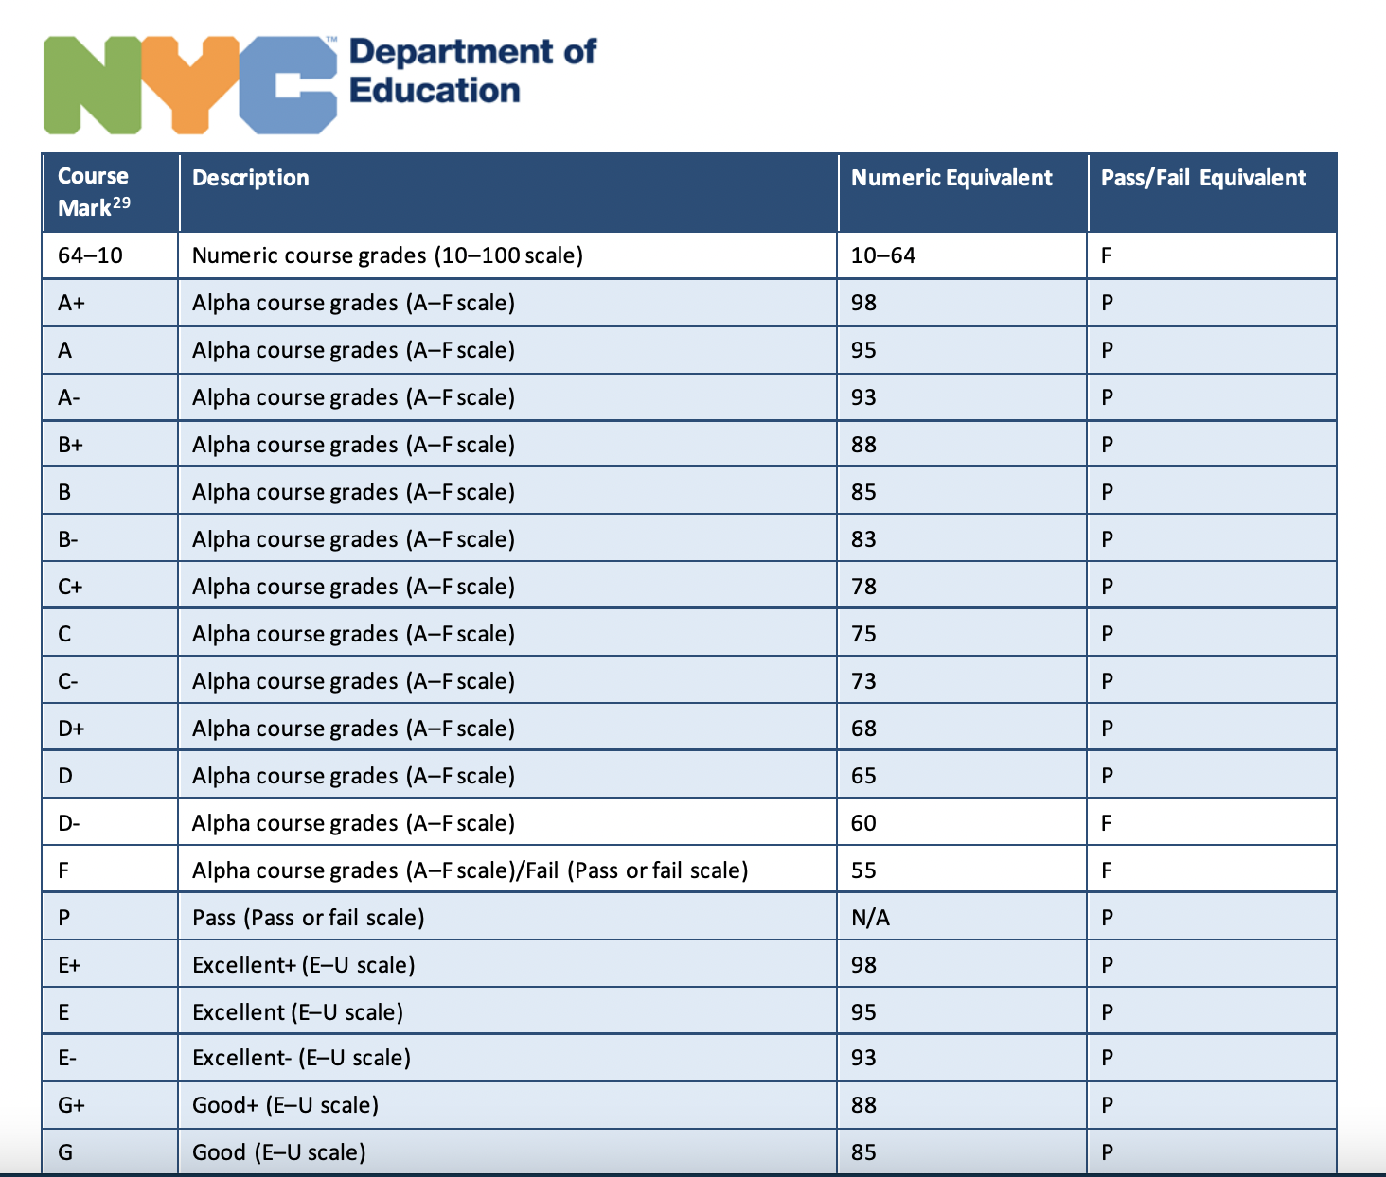

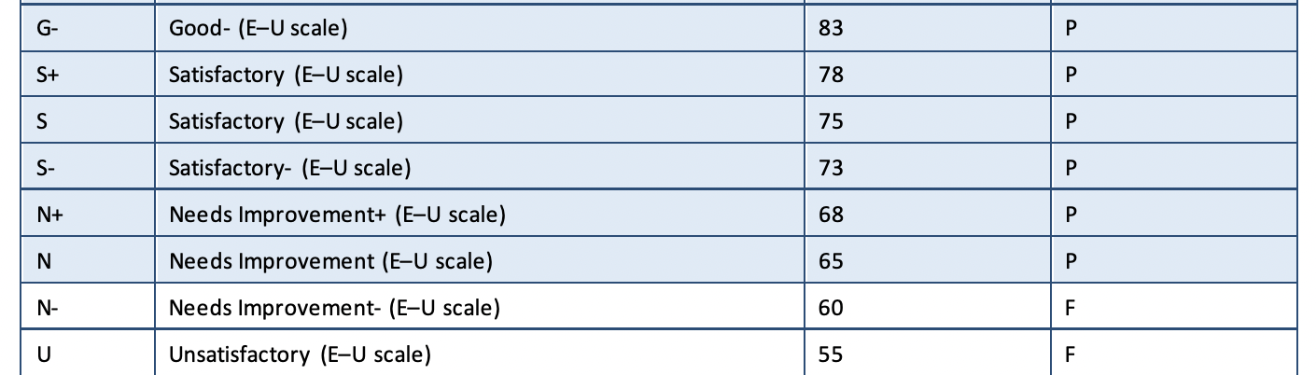

**Grading Guidelines**

Student mastery of subjects may be assessed in many ways. It is not necessary to receive a grade for every paper produced. Teachers will provide feedback for their assignments and activities; however, this does not always need to be in the form of a grade.

Assessments are a way in which teachers evaluate student understanding of the core standards. Types of assessments that may be counted toward the final grade include:

· Announced Quizzes

· Unannounced Quizzes

· End of Chapter Assessments

· End of Unit Assessments

· Projects

· Teacher Created Tests /Quizzes

· Performance Tasks

Performance assessments and daily activities will be used to assess mastery of the Next Generation Standards. These include, but are not limited to:

· Classroom Participation

· Classroom Discussions

· Oral responses

· Written Responses

· Experiments

· Teacher Observation

· Research Projects

· Checklist of Skills

· Portfolios

· Enrichment

· Projects

· Class Activities

· Exit slips

· Quick checks

# **Rubrics**

Rubrics will be given out along with assigned writing pieces and special projects. These rubrics will describe what the task is, how to complete the task and how it will be scored. Rubrics are given to students as a tool to guide them in completing their writing pieces. The rubric for any given writing assignment will be reviewed in class with the students. This will give them a better understanding of what is expected of them.

# 

# 

# **Breakdown of the % of Student Scores Grades 1-5**

Report card grades will be calculated using the following breakdown:

Classwork and Class Projects – 35%

Class Participation – 30%

Homework & Home Projects – 5%

Formal Assessments (tests & quizzes) – 30%

# 

# **Breakdown of the % of Student Scores Grades Kindergarten**

Report card grades will be calculated using the following breakdown:

Classwork and Class Projects – 40%

Class Participation – 40%

Homework & Home Projects – 5%

Formal Assessments (tests & quizzes) –15%

# **Homework Grades**

Homework is an effective tool in teaching responsibility, study habits and skills. It is an extension of the child’s school day and allows the home to be involved in the student’s academic success. Homework should be purposeful, age appropriate, and related to what your child learned during the school day. Homework should be a review of the work previously taught. No new skills will be assigned.

The following shows how much time your child should be spending on homework each night.

Kindergarten and 1st grade: 15-20 minutes

Grade 2: 20-30 minutes

Grade 3 and 4: 30-40 minutes

Grade 5: 50-60 minutes

Homework will constitute 5% of the overall grade for each subject area. Late homework is subject to a deduction in grade. Any homework that is over one week late will be given a zero and calculated into that child’s overall homework grade for that subject.

**Distribution of Report Cards**

Report Cards will be given out 3 times a year. These times correspond with parent teacher conferences and the last day of school. Parent teacher conferences will be held remotely for the 2022-2023 school year via zoom or a phone call. Report cards will be available to parents via the My Student Portal. You can click on this link to access your child’s report card and grades: [www.schoolsaccount.nyc](http://www.schoolsaccount.nyc) **YOU MUST REGISTER IN ORDER TO VIEW YOUR CHILD’S REPORT CARD.**  Please let teachers know if you are unable to attend the parent-teacher conference times and a meeting can be scheduled for another date.

**Marking Period Grades:** Each marking period, students will be given an isolated score for each subject area. The scores for that marking period will be averaged. A semester grade for that marking period will be assigned on the report card. Each new marking period the child will start over with the ability to improve their grade or lower their grade according to their scores in any given subject area.

**Final Grades:** The final grade on the student report card will represent their overall achievement for the entire school year. The final grade will be a cumulative grade of the entire year’s performance in that subject area.

2023-2024 Report Card Timeline

Thursday, November 2, 2023

Thursday, March 7, 2024

Teachers usually schedule appointments with parents throughout the week of report cards. Please check your child’s folder to make an appointment prior to the date.

**Students with an IEP**

The teacher will grade students with an Individualized Education Plan (IEP) in accordance to their IEP. All accommodations on the IEP will be considered before assigning a grade on the report card. Parents will receive a progress report based on their child’s IEP goals at the time of report cards.

## 

## 

## 

**Attendance Report Cards**

Attendance Report Cards will also be given out 3 times a year in conjunction with academic report cards. They correspond with parent/teacher conferences so that you may have an accurate portrayal of how your student’s attendance is impacting their academics. Please see a sample attendance report card below:

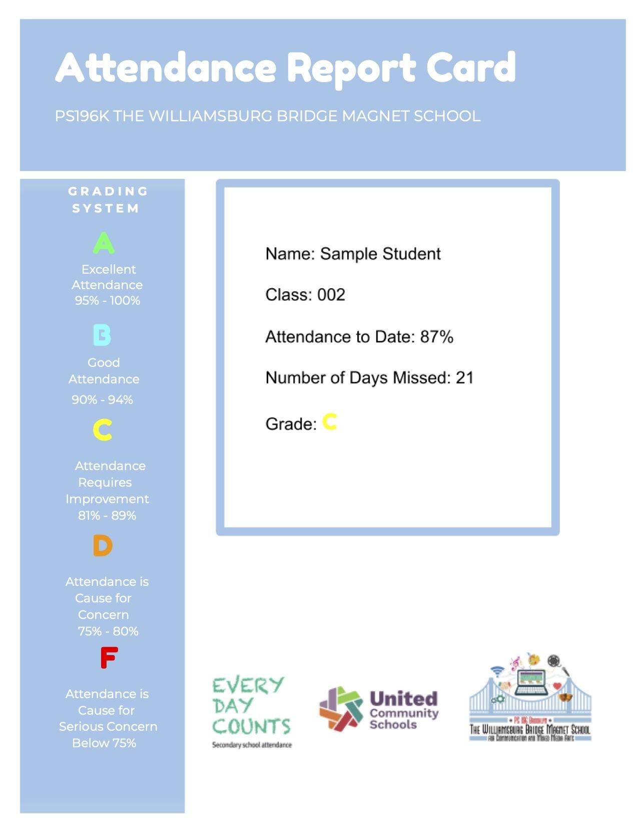

**Marking Period Grades:** Each marking period, students will be given an isolated score for each subject area. The scores for that marking period will be averaged. A semester grade for that marking period will be assigned on the report card. Each new marking period the child will start over with the ability to improve their grade or lower their grade according to their scores in any given subject area.

**Final Grades:** The final grade on the student report card will represent their overall achievement for the entire school year. The final grade will be a cumulative grade of the entire year’s performance in that subject area.

**Students with IEPs**

Students with IEPs will have services provided to them throughout the school day. The teacher will grade the students with an Individualized Education Program (IEP) will be considered prior to assigning a grade on the report card.

**Homework**

Home will be given regularly in grades Kindergarten - 5th. It is important that students complete all of their homework assignments since homework is considered to be a review of what was taught during the school day. Homework is also an effective tool in teaching responsibility, study habits and skills. Homework will count as 10% of your child’s report card grade. Students in grades 3K and Pre-K will receive Optional Assignments that can be completed at home with the parent.

## **Dress Code Policy**

196WBMS students are required to wear uniforms. The uniform can be found at several local stores and consists of: Light blue collared shirt (long sleeve or short sleeve), navy blue shorts/pants or skirts. 196WBMS spirit wear can also be considered part of the dress code.

## **Student Privacy Annual Notices to Families**

The DOE takes the confidentiality of information about students very seriously. There are several federal and state laws, such as the Family Educational Rights and Privacy Act (FERPA) and New York State Education Law 2-d, and local regulations, such as [Chancellor’s Regulation A-820](https://www.schools.nyc.gov/docs/default-source/default-document-library/a-820-6-29-2009-final-combined-remediated-wcag2-0), that protect students’ “personally identifiable information” (PII). These laws also place responsibilities on the DOE and outside parties that are given access to children’s PII, including the requirement for the DOE and schools to provide families with the following annual notices:

* [Annual FERPA Notification](https://www.schools.nyc.gov/about-us/policies/data-privacy-and-security-policies/annual-ferpa-notification) (scroll to the bottom of the page for parent letter and translations); and
* [Parent Bill of Rights for Data Privacy and Security](https://www.schools.nyc.gov/school-life/know-your-rights/parents-bill-of-rights-for-data-privacy-and-security).

You may distribute these notices in various ways, including as part of your school’s handbook, backpacking them home, posting them on school bulletin boards, and/or displaying them on your school’s website.

For more information, review the [Student Data Privacy and Security Policies,](https://infohub.nyced.org/nyc-doe-topics/Policies/student-data-privacy-and-security-policies) the [Data Privacy and Security Compliance Process](https://infohub.nyced.org/in-our-schools/policies/data-privacy-and-security-compliance-process), and last year’s [Student Privacy Training](https://nam10.safelinks.protection.outlook.com/?url=https://platform.welearnnyc.org/d2l/home/791133&data=05%7c01%7cMToledo%40schools.nyc.gov%7ca2e8605e1daa4842ccbf08dba4a051fe%7c18492cb7ef45456185710c42e5f7ac07%7c0%7c0%7c638284780699266433%7cUnknown%7cTWFpbGZsb3d8eyJWIjoiMC4wLjAwMDAiLCJQIjoiV2luMzIiLCJBTiI6Ik1haWwiLCJXVCI6Mn0%3D%7c3000%7c%7c%7c&sdata=Neb/wXOCU0qagQKaTgZQMaKXilFTQosWlJ7bB0C2EzQ%3D&reserved=0) in WeLearn. Additionally, please note these policy highlights:

* You and your staff must not disclose student information to union representatives. Union representatives are not considered school officials and generally cannot be copied on emails that contain student information without parents’ or eligible students’ consent. For more information, refer to the Disclosure to Outside Parties section of the [Student Data Privacy and Security Policies](https://infohub.nyced.org/nyc-doe-topics/Policies/student-data-privacy-and-security-policies) InfoHub page.
* You must redact incident (OORS) reports before sharing them with a family so that PII for other students, including names, contact information, parents’ names, grade levels, etc., are not disclosed to the family receiving the report.
* Student helpers and family/community volunteers must not receive or have access to student information, such as students’ names, attendance, or contact information, as part of their responsibilities.

For questions, email your [senior field counsel](https://infohub.nyced.org/nyc-doe-topics/legal/office-of-general-counsel-overview-contacts/senior-field-counsel-2).

## **Discipline Code**

The Discipline Code applies to all students and includes both support and interventions, as well as disciplinary responses.

<https://www.schools.nyc.gov/school-life/know-your-rights/discipline-code>

## **Cyberbullying and Digital Citizenship**

Chancellor's Regulation (CR) A-832 prohibits any student from creating a hostile environment for any other student by engaging in student-to-student discrimination, harassment, intimidation, and/or bullying at home or in school. Consequences are outlined in the NYC DOE Discipline Code. We will not tolerate bullying or harmful behaviors from any student including verbal, written, physical, or digital.

Both parents and teachers need to help students be good digital citizens. They both need to support students in using the internet in ways that are safe, responsible, and appropriate. They also help students follow the rules and act in ways that lead to effective digital learning. Here are the responsibilities expected of, parents and students:

**Parent Responsibilities**

Make sure your child acts responsibly. This includes knowing and understanding the Discipline Code, Internet Acceptable Use and Safety Policy (IAUSP), and Social Media Guidelines for Students 12 and Younger or 13 and Older.

* Keep track of your children's online use when they are not in school—including mobile apps, online games, and other social media
* Share values with your children and talk with them about what is—and is not—acceptable online behavior.

**Student Responsibilities**

Follow the rules

* Follow all school and class rules for using technology
* Act responsibly to all—both online and face-to-face
* Collaborate in positive ways that help you learn
* Use technology to support an inclusive school community
* Stay safe
* Only use accounts that belong to you.
* Protect passwords—don’t share them with others
* Don’t automatically save passwords on school devices
* Don’t give out personal information online without your parent’s permission
* Have permission from a parent before meeting anyone in person that you have met only online

Take care of things

* Respect and care for both:
  + Student work (yours and your peers)
  + Devices

Take care of each other

* Only download music, photographs, or video if you have permission from your teacher
* Follow the owner’s instructions for use
* If you don't know whether you can use something you found online, ask the owner for permission
* Follow your teacher’s directions for fundraising online

**See something that is inappropriate, threatening, or unkind? Here is what you can do:**

* Reach out to a trusted adult
* Email RespectForAll@schools.nyc.gov
* Call Respect for All at 212-374-2350

Students who do not act responsibly may face the consequences explained in the Discipline Code and Chancellor’s Regulations.

**Cell Phone Policy**

According to the Chancellor’s Regulation A-413 students are permitted to bring cell phones and other electronic devices to school. **At WBMS, all electronic devices must be turned off and stored in students’ backpacks during the school day**. Phones may not be used to talk, take pictures, play games, record or text during school hours including recess and afterschool programs.

As per the Chancellor’s Regulation A-413:

○ Cell phones, computing devices and portable music and entertainment systems may not be turned on or used during fire drills or other emergency preparedness exercises.

○ Cell phones and portable music and entertainment systems may not be used on or used during the administration of any school quiz, test or examination.

○ Computing devices may not be turned on or used during the administration of any school quiz, test or examination, except as authorized by the school, or pursuant to an IEP or Section 504 accommodation.

○ Cell phones, computing devices, and portable music and entertainment systems may not be used in locker rooms or bathrooms.

Should a student violate the guidelines listed above the following steps will occur:

○  **1st Infraction** – Warning to put device into backpack

○  **2nd Infraction** – Confiscation of device to be placed in main office and returned at dismissal

○  **3rd Infraction** – Confiscation of device and parent will be contacted to pick up the device from the main office.

Students who use cell phones, computing device, and or portable music and entertainment system in violation of any provision of the DOE’s Discipline Code, the school’s policy, Chancellor Regulation A-413 and /or the DOE’s Internet Acceptable Use and Safety Policy will be subject to discipline in accordance with the NYCDOE Citywide Behavioral Expectations.

**If a parent needs to speak to his/her child concerning an emergency during the school day he/she should contact the main office at (718) 497-0139. Additionally, should a child need to contact his/her parent or guardian during the school day he/she will be allowed to use the school phones.**

**School Safety Plan**

At the beginning of each year, all schools develop a School Safety Plan. The plan outlines the procedures that the school uses everyday and in cases of emergency to provide a safe and secure environment in which effective teaching and learning take place. Each plan is approved by the Office of Safety and Youth Development and NYPD. In order to ensure safety for all students and staff, the specific emergency response plans and procedures of the School Safety Plan must remain confidential.

The School Safety Plan addresses the following major areas:

School/Program/Academy Information: This section lists the staff members, hours or operation, chain of command, class schedules, dismissal schedules, extra-curricular activities, and use of special facilities (such as swimming pools)

Medical Emergency Response Information: This section outlines procedures for the dissemination of health recommendations, and for maintaining and accessing health supplies and trained medical personnel. It also outlines the use and storage of the AED.

We recommend you register with Notify NYC to receive information about emergency events. You can call 311 for additional information about a school during an emergency. Please view the following chart for the types of emergency drills we conduct throughout the school year. Please note some drills are unannounced.

## **Emergency Readiness**

We recommend you register with Notify NYC to receive information about emergency events. It is also important that you create a NYC Schools Account (NYCSA) to receive “real-time” emergency notification from school emergencies. You can call 311 for additional information about a school during an emergency.

**General Response Protocol**

Schools train and drill all staff and students in the General Response Protocol, which describes what to do in an Evacuation, Shelter-In, or Lockdown. The training is tailored for different grade levels so that students aren’t upset by the information.

Schools also send home a copy of the General Response Protocol, to help you talk to your children about emergency readiness in school.

The General Response Protocol gives schools instructions to follow when an emergency happens. It uses common language to identify the steps to take until first responders arrive.

In every incident, school administrators will first call 911. Then they will look at the unique situation and decide:

* whether to lock down (soft or hard), shelter-in, or evacuate.
* if any instructions should be changed to fit the specific circumstances.

**Lockdowns**

**Soft Lockdown: No Imminent Danger**

Administrative teams, Building Response Teams, and School Safety Agents will meet at the designated command post for further direction.

**Hard Lockdown: Imminent Danger**

No one should sweep the school in a hard lockdown. All individuals, including School Safety Agents will take appropriate lockdown action and await the arrival of first responders. In a Hard Lockdown, there may be instances where additional action is needed to minimize the danger to individuals. Adults and students will also need to consider all available options during an incident. They may need to run out of the building to remain safe and contact 911 if they are in an area that allows them to do so. They may need to hide (remain in lockdown) to ensure that they are behind a locked door and remain silent, or if faced with an imminent threat in their room or office, they may need to confront their attacker.

**In Any Lockdown**

* A Public Address (PA) announcement made two times:
  + Attention: We are now in soft/ hard lockdown. Take proper action.
* Students are trained to move out of sight and keep silent.
* Teachers are trained to:
  + Check the hallway outside of their classrooms for students, lock classroom doors, and turn off the lights.
  + Move out of sight and keep silent
  + Wait for first responders to open door, or for the message:
    - The Lockdown has been lifted followed by specific directions
    - Take attendance and account for missing students by contacting the main office.

**Evacuations**

Often, the fire alarm system alerts staff and students to start an evacuation.However, there may also be times when a Public Address announcement starts an evacuation.

* Announcements will begin with “Attention” followed by specific directions.They are made two times.
* Students are trained to:
  + Leave belongings behind
  + Form a single file line
  + In cold weather, students should be reminded to take their coats.
  + However, students wearing exercise or gym clothes will not return to the locker room.
  + Students without winter coats will be taken to safe, warm location as quickly as possible.
* Teachers are trained to:
  + Grab evacuation folder (with attendance sheet and Assembly cards).
  + Lead students to evacuation location as identified on Fire Drill Posters.
  + Always listen for additional directions
  + Take attendance and account for students.
  + Report injuries, problems, or missing students to school staff and first responders using Assembly Card method.

**Shelter-in**

There is a Public Address announcement made two times:

* Attention. This is a shelter-in. Secure the exit doors.
* The Shelter-In directive stays in effect until it is ended by a Public Address announcement
  + The Shelter- In has been lifted
* Students are trained to:
  + Remain inside the building
  + Conduct business as usual
  + Respond to specific staff directions
* Teachers are trained to:
  + Be more aware of their surroundings
  + Conduct business as usual

BRT members, floor wardens, and Shelter- In staff will secure all exits and report to specific post assignments

**Hold**

The Hold response calls for no movement throughout the building until the “all clear” is given. While in Hold response, instruction and office tasks may continue as normal but no one may leave the room they are in until the Hold has ended.

Hold is initiated when there is a condition inside the school building, and the immediate need to address the condition requires staff, students, and visitors to remain in place and conduct business as usual until the “All Clear” is announced.

Hold might be initiated to manage an incident in the building that does not place the school community in danger, or whenever directed by First Responders Hold does not replace a soft or hard lockdown.

The Building Response Team and School Safety Agents will sweep the building. Anyone found in the restrooms, hallways, stairwells, or the lobby will be taken to a designated area until the “All Clear” announcement is made.

Announcements must be made to remind everyone to disregard any “end of class” signals. No one may enter or leave their room or office until the announcement is made indicating that the “All Clear” has been issued and the building can return to regular operation.

During a Hold, anyone entering the school must be informed of the Hold. If students are returning from lunch, they must be escorted to a designated area where they can remain, with proper supervision, until the “All Clear” announcement is made.

## **Academic Programs**

***Houghton Mifflin Harcourt’s Into Reading***

Children are born with a love of learning. When we give them high-quality books that intrigue and challenge, we empower them to pursue their natural curiosity and discover their interests. As students build a strong foundation in reading, writing, listening, and speaking skills, they develop a confidence in themselves that ensures lifelong learners emerge.

HMH Into Reading™ is differentiated by design to offer a balanced approach to literacy instruction, support teachers in developing a culture of learning and growth, and help all learners believe in the power of "I can."

***For further information, explore the website at:*** [***https://www.hmhco.com/programs/into-reading***](https://www.hmhco.com/programs/into-reading)

***enVision Math 2.0***

enVisionmath2.0 is a comprehensive mathematics curriculum for Grades K-5. It offers the flexibility of print, digital, or blended instruction. enVisionmath2.0 provides the focus, coherence, and rigor needed to meet your standards. Project-based learning, visual learning strategies, and extensive customization options empower every teacher and student.

***For more information, you can visit their website at:*** [***https://www.savvas.com/index.cfm?locator=PS2xBv***](https://www.savvas.com/index.cfm?locator=PS2xBv)

***Fundations***

Fundations is a multisensory and systematic phonics, spelling and handwriting program that benefits all K-3 students. Fundations is designed as a whole-class, general education program used for prevention (Tier 1) purposes.

***Heggerty***

Heggerty is a Phonemic Awareness Curriculum that provides students with consistent and repeated instruction, and this transfers to developing a student’s decoding and encoding skills.All students participate in the lessons as part of the Tier 1curriculum in grades K-3.

For more information, you can visit their website at: <https://www.savvas.com/index.cfm?locator=PS2xBv>

***I-Ready***

i-Ready is an online program for reading and/or mathematics that will help your student’s teacher(s) determine your student’s needs, personalize their learning, and monitor progress throughout the school year. Please review the parent guide below for more information on how to use i-Ready and family tips and tricks:

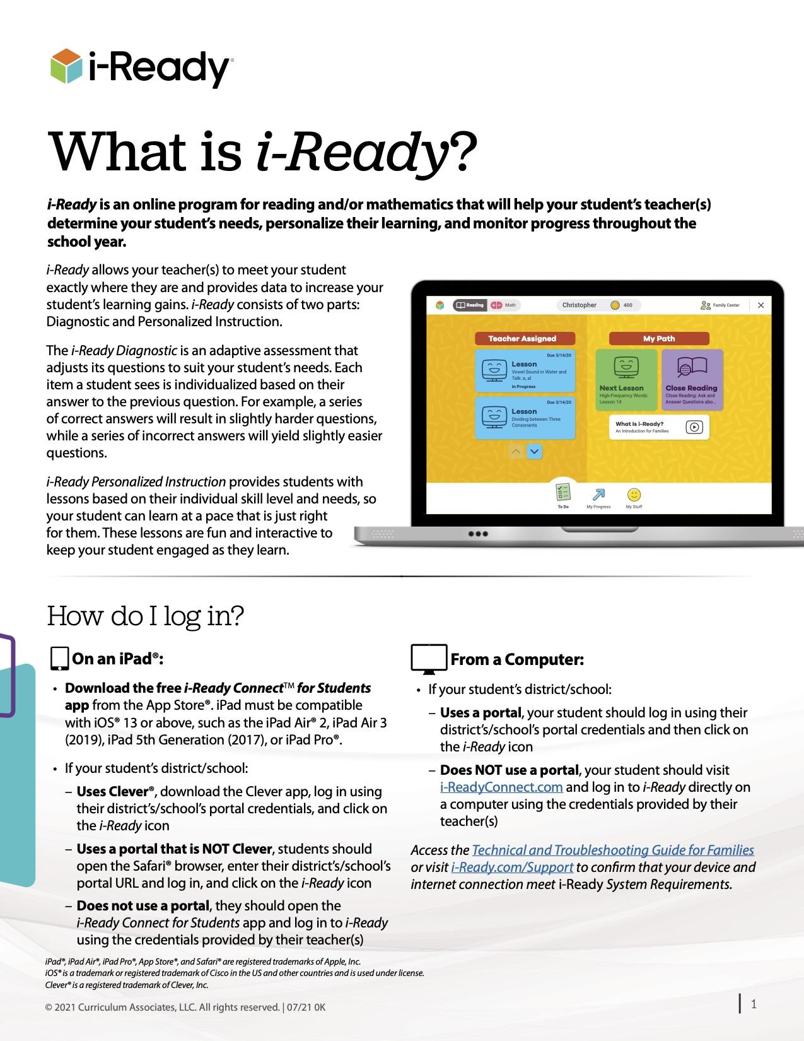

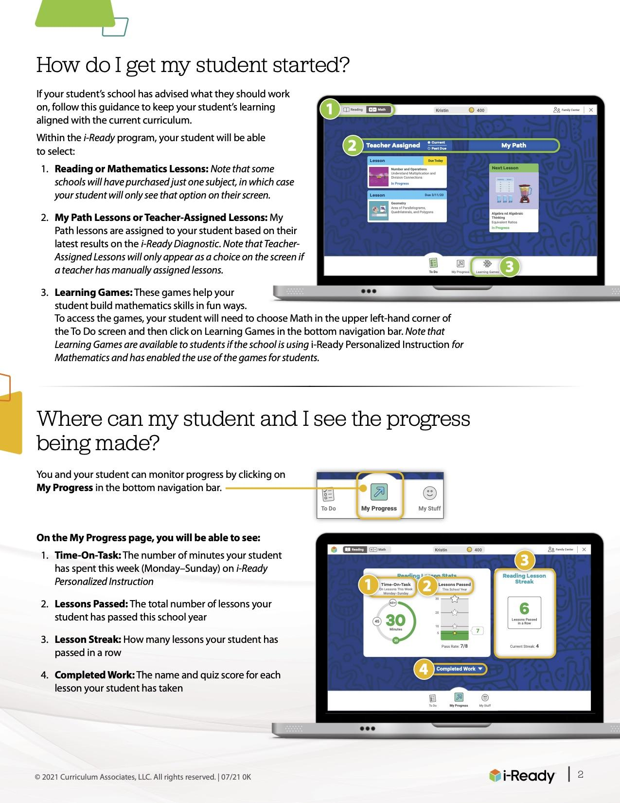

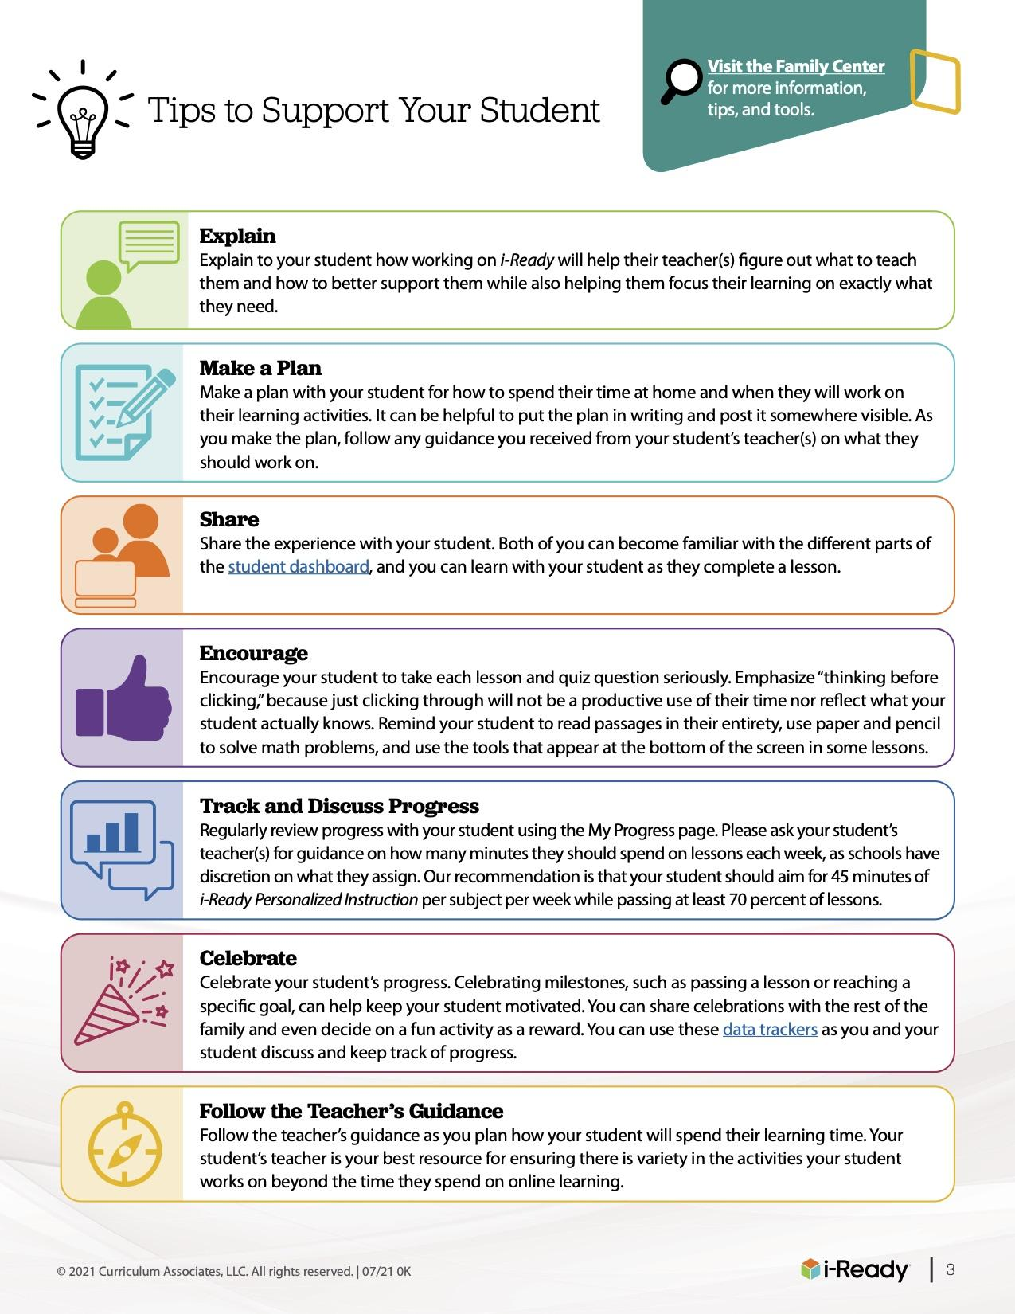

***Social-Emotional Learning***

At 196WBMS, we feel that a child's social-emotional development is just as important as their academic progress. This year, we are utilizing the Sanford Harmony Program, which provides everyday practices and lessons covering the following important topics:

***Diversity and Inclusion:*** Boys and girls learn to recognize and appreciate one another’s similarities and differences while promoting a community environment in and outside of the classroom.

***Empathy and Critical Thinking:*** Children develop empathy (the ability to identify with and understand another person’s emotions), reduce stereotyped thinking, and learn critical thinking skills.

***Communication:*** Healthy and unhealthy intergender communication patterns are explored, and boys and girls practice effective ways of engaging with others.

***Problem solving:*** Students learn constructive approaches to resolving conflict, focusing on conflict-resolution steps that facilitate healthy relationship patterns.

***Peer Relationships:*** Boys and girls practice positive social skills and learn the qualities that are important to friendship, the consequences of bullying, and how to provide peers with support.

***For further information, you may view Sanford Harmony’s website at:*** [***https://www.sanfordharmony.org/***](https://www.sanfordharmony.org/)

## **Schoolwide Programming**

**Brighter Bites**

Brighter Bites is a bimonthly produce and nutrition education program that provides families with fresh produce every other Thursday. Please review below information for distribution dates and volunteering. Enrollment link: [https://fs27.formsite.com/brighterbites/enroll23/](https://nam11.safelinks.protection.outlook.com/?url=https%3A%2F%2Ffs27.formsite.com%2Fbrighterbites%2Fenroll23%2F&data=05%7C01%7CMEverett%40ucsuft.org%7Cf895f42f59e34ce722b408db9f3f0347%7Cda02d0cf35ff4d259837a92821130bb1%7C1%7C0%7C638278865235425313%7CUnknown%7CTWFpbGZsb3d8eyJWIjoiMC4wLjAwMDAiLCJQIjoiV2luMzIiLCJBTiI6Ik1haWwiLCJXVCI6Mn0%3D%7C3000%7C%7C%7C&sdata=KEYjFQiOrUkVnGwi5jKjhRjhULbpzxH0S0DNTFeS0TE%3D&reserved=0)

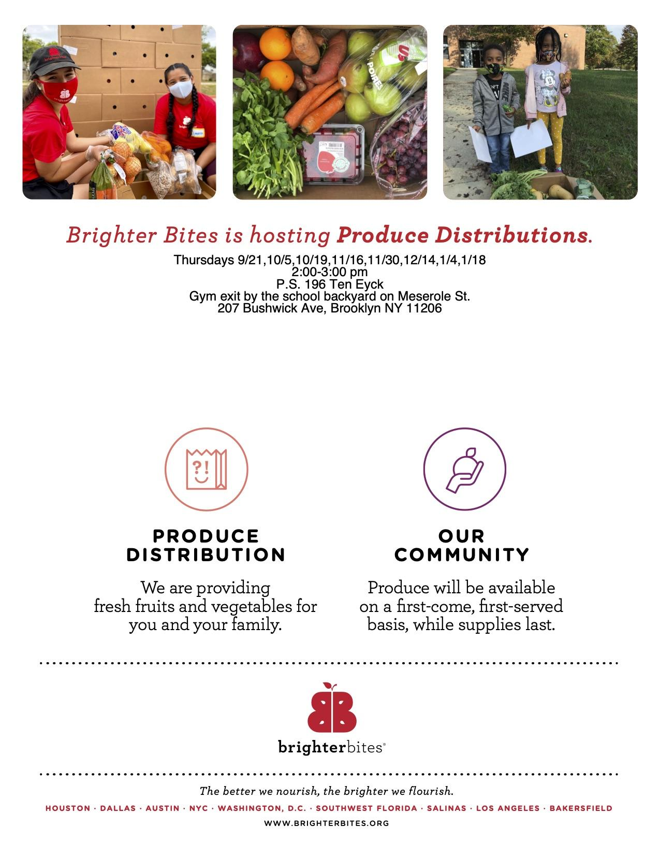

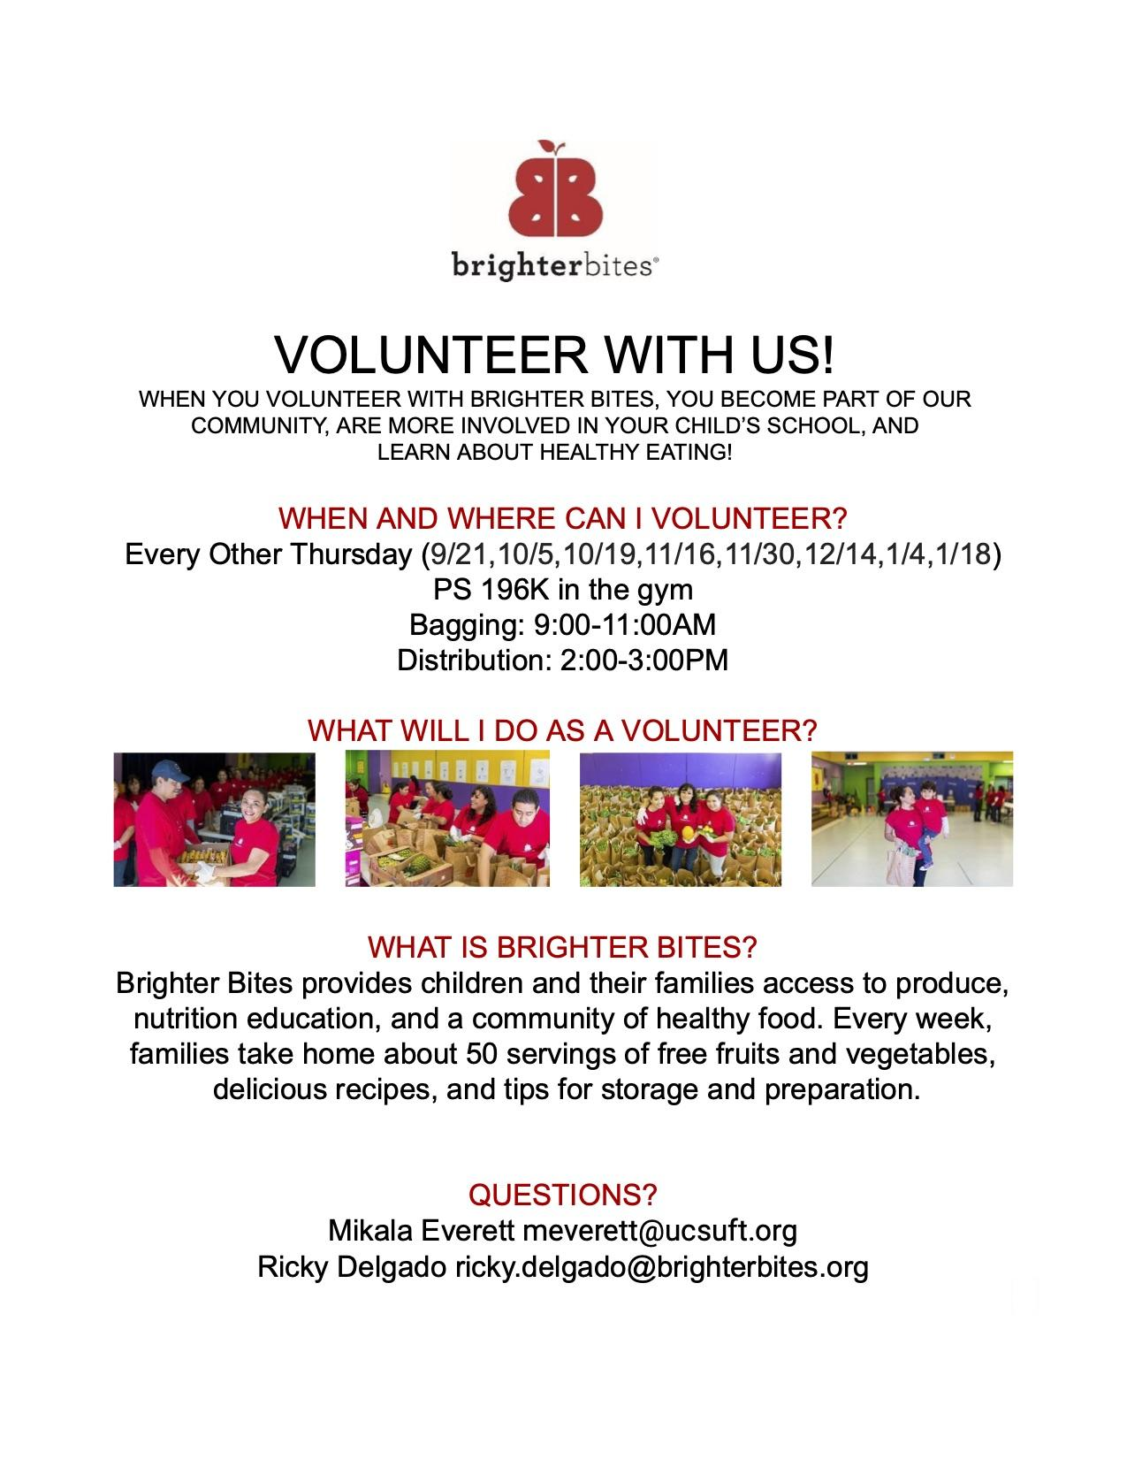

**Grand Street Settlement Afterschool**

Grand Street Settlement is a free after school program for K-5 families. Priority is given to returning students and those with siblings so please speak with the school secretary, Lina D’Alto or the Program Director, Ashley Rodriguez, if you are interested in applying.

**World Explorers**

World Explorers is a paid after school program for 3K/PK families. Enrollment is open to all grades with priority for the 3K-K age group. Please visit this link to find out more information about program offerings, tuition prices, and more: <https://www.brooklyn.explorerkids.us/so/1aOdv-bzV?languageTag=en>

**NYU Dental/Mental Health Clinic**

We are partnered with NYU Langone to provide in-school dental services such as routine cleanings and light work so that students do not have to miss valuable instructional time to visit the dentist. We have a full suite on the 3rd floor where students visit the dentist.

This school year we will also be opening a Mental Health Clinic to provide students and families with counseling resources, family and group therapy, as well as access to a licensed professional in the school building that can refer students and families to a psychiatrist.

For more information about enrolling in these services, please contact the Community School Director, Mikala Everett ([meverett@ucsuft.org](mailto:meverett@ucsuft.org)) or the Parent Coordinator, Maria Rodriguez ([mrodriguez3@schools.nyc.gov](mailto:mrodriguez3@schools.nyc.gov)).

**New York Cares**

New York Cares generously partners with our school to provide backpacks, winter coats, holiday gifts, in-school programming and volunteer support. For more information about our work with New York Cares please contact the Community School Director, Mikala Everett ([meverett@ucsuft.org](mailto:meverett@ucsuft.org)).

**Pace University/City College**

We work with Pace University/City College every year to provide student teachers an opportunity to gain classroom experience and provide support to our educators.

**Family Health Challenge**

Family Health Challenge is an annual nutrition education program for 2nd Grade students. Doctors in residence come into the classroom once a week to talk about living a healthy lifestyle and nutrition and wellness.

## **NYCSA Parent Portal**

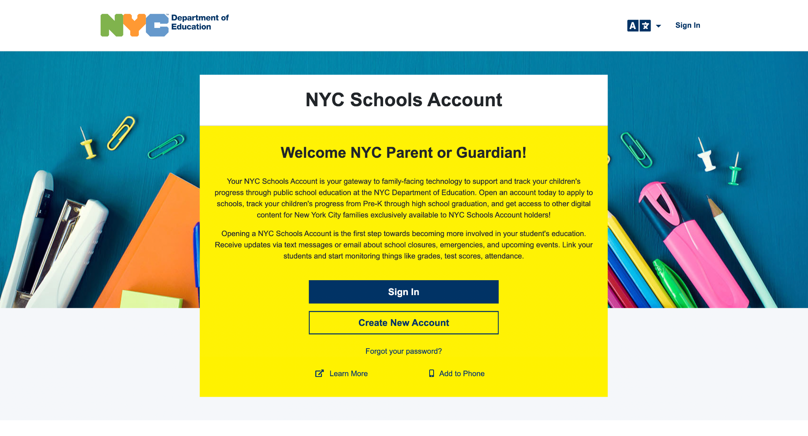

**The new NYC Schools Account (NYCSA) Portal** will allow you to:

* See your students grades, test scores, and more in MY Student
* Take classes in Parent University
* Report Bullying
* Access forms for your child
* Reset your child’s DOE account password
* Access SupportHub

**All with one login!**

**If you have any questions or concerns you can contact the Parent Coordinator Maria Rodriguez @ 718-497-0139.**

***10 important back to school tips for parents in 2023***

***Summer vacations are coming to an end, and it’s time for kids to head back to school. A school is not only a place of learning for children, but also a place for socializing and enjoyment. So, while the anticipation of returning to school after a long holiday may excite some, it may not excite others. If parents are calm, helpful, and comforting, their children will feel confident and capable. Listed below are 10 important back to school tips for parents to assist their children in adjusting to their new surroundings.***



***Back to School Tips For Parents in 2023***

***1. Prepare and plan ahead of time***

***One of the most crucial back-to-school tips for parents is to first make a list of items that contains all of the necessary clothing, lunch boxes, backpacks, and materials that can be purchased ahead of time. Make sure you don’t go shopping at the last minute.***

***2. Plan bedtime and wake-up routine in advance***

***Starting a bedtime routine two weeks prior to the start of school is an important back-to-school tip for parents. Preparing children for bedtimes will help them stick to a regular sleeping routine and will relieve you of one concern. Make sure your kid receives a minimum 8-10 hours of sleep each night.***

***3. Prepare a weekly meal planner and to-do list***

***The easiest strategy to ensure a stress-free morning routine is to prepare a to-do list for an entire week including the*** [***meal preparation***](https://www.archanaskitchen.com/weekly-meal-plans/)***,your kids outfits, and keeping a watch on your kids weekly school time-table. This will save your and your kids last minute hustle bustle.***

***4. Prepare a safety first mindset***

***The safety first approach is a crucial aspect of preparing your children for the first day of school. Make sure your children are aware of the surroundings as well as their own physical safety. The parents should teach their younger ones their name, how to spell it, their phone number, and the phone number of a responsible adult.***

***5. Communication is the key***

***Communicate with your kids to know their sentiments, and how you can offer help to make their first day of school a memorable one. This discussion will make your kid’s back to school journey cheerful.***

***6. Meet the new teachers***

***It is critical to visit your child’s school at least one week before the start of the new school year. Allow your child to become acquainted with the new classrooms and new teachers. Try to find a way to meet with the teachers one-on-one.***

***7. Discuss bullying with your children***

***Teach your kids to*** [***deal with bullies***](https://www.wikihow.com/Deal-with-Bullies-at-School#:~:text=%20How%20to%20Deal%20with%20Bullies%20at%20School,action.%20It%20takes%20more%20than%20an...%20More%20) ***by reporting them to a teacher, counselor, or yourself. Explain to them the harmful effects caused by bullying. Make sure they respect their batch mates.***

***8. Setup a storage unit***

***Setup a storage unit by choosing an appropriate location to store everything relevant to school, such as your kids outfits, bags, and school accessories. This method will help you and your kids to locate the things whenever needed. Allow your kids to stock the school materials and keep it clutter-free.***

***9. Create a pleasant environment at home***

***It is very important to create a friendly and positive atmosphere for doing homework once school starts. Set up a permanent study room for your kids which is free from distractions and provides a peaceful and positive learning environment.***

***10. Create a list of enjoyable after school activities for kids***

***Allow your kids to participate in innovative after-school activities in addition to their homework to keep them entertained. Playing board games, creating artwork etc. are some examples.***

**We hope that this Digital Handbook has helped you.**

**Please note that this handbook will be updated often to reflect any changes in policies and procedures that may occur.**

**Thank you for making this year the BEST one yet.**

**We are in this TOGETHER!**



**Any further questions please email your teacher, our Parent Coordinator Maria Rodriguez at mrodriguez3@schools.nyc.gov, or**

**reach out to the196WBMS main office at (718) 497-0139.**